Eric Kearney
CS 390S
Professor Feng Jiang

In-Class Exercise 1 (Due Oct 1st)
ALL code has been done in Python
Open book, Open Note, you could also discuss with your neighbors and the teacher.
After you finished all the problems, please submit to blackboard or submit the hardcopy to the teacher. Students who are absent when the exercise was handed out are NOT allowed to submit.

- Is gamma correction same as adding gamma noise to the image?
No.

- A grayscale image is generated with poor (too dark) lighting condition. Some image region with lower intensity is too dark to show all the detail features. How could you enhance the image?
Please finish the code fragment.

Adrian Rosebrock’s site helped me immensely here: https://www.pyimagesearch.com/2015/10/05/opencv-gamma-correction/

import cv2 as cv
import numpy as np

img = cv.imread(‘./test.bmp’)

def adjust_gamma(image, gamma=1.0):
# build a lookup table (i.e. dictionary)
# mapping the pixel valus [0, 255] to their
# adjusted gamma values
invGamma = 1.0 / gamma
table = np.array([((i / 255.0) ** invGamma) * 255
for i in np.arange(0, 256)]).astype("uint8")

# apply gamma correction using the lookup table
return cv.LUT(img, table)

adjusted = adjust_gamma(img, 1.5)
cv.imwrite(‘./test_output.bmp’, adjusted)

- In order to extract the edge information of a grayscale image, if only the diagonal neighbors within the 8 neighborhood are considered, how could you extract the edge information by applying a spatial filter (how to design the spatial filter)?
Four diagonal neighbors are equally important.
Please finish the code fragment.

import cv2 as cv
import numpy as np

img = cv.imread(‘./test.bmp’)

def detect_edge(image):
kernel = np.matrix([[1, 0, 1], [0, -4, 0], [1, 0, 1]])
return cv.filter2D(image, -1, kernel)

edge_detected = detect_edge(img)

cv.imwrite(‘./test_output.bmp’, edge_detected)

- In question 3, if the upper two diagonal neighbors and the lower two diagonal neighbors are not equally important, say the upper two and lower two neighbors weight 0.6 and 0.4 respectively, how could you extract the edge information by applying a spatial filter (how to design the spatial filter)?

import cv2 as cv
import numpy as np

img = cv.imread(‘./test.bmp’)

def detect_edge(image):
kernel = np.matrix(
[[0.6, 0, 0.6], [0, -2, 0], [0.4, 0, 0.4]])
return cv.filter2D(image, -1, kernel)

edge_detected = detect_edge(img)

cv.imwrite(‘./test_output.bmp’, edge_detected)

- What spatial filter(s) are equivalent with applying the high pass frequency filters? (Please write down a couple spatial filter examples.)

Laplacian, sobel.

What spatial filter(s) are equivalent with applying the low pass frequency filters?
(Please write down a couple spatial filter examples.)

Gaussian, averaging, median.

- What is the equivalent spatial filter with the Gaussian filter of frequency domain? And why?
(Remember that a frequency filter is usually multiplied with the frequency transform of the original image.)

Averaging filter, both blur the image.

- How to perform image sharpening if only the spatial Gaussian filter can be used?

Please finish the code fragment.

import cv2 as cv
import numpy as np

img = cv.imread('./test.bmp')
gaus = cv.GaussianBlur(img,(5, 5),0)
difference = np.subtract(img, gaus)
alpha = 2
sharpened = gaus + alpha * difference

cv.imwrite(‘test_output.bmp’, sharpened)

- How many bright points could you get from the Hough transform of the following image?
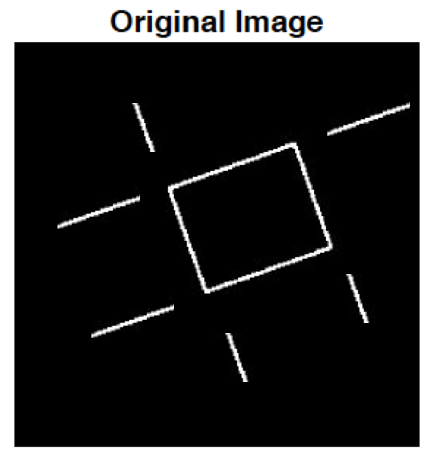
4.

- Please finish the program of generating uniform noise (with zero mean, range [a, b] = [-0.05, 0.05]) and adding the uniform noise to the original image. (Requirement: do not use other matlab functions except “rand()” for uniform noise generation. )
Please finish the code fragment.

import cv2 as cv
import numpy as np

img = cv.imread('./test.bmp', 0)
# Normalize the input image
img = np.divide(img, 255)

# Create a matrix the same size as the image
# This matrix contains values between -0.05 and 0.05
noise = 0.10 * np.random.rand(img.shape[0],
img.shape[1]) - 0.05

noisy_image = np.add(img, noise)

cv.imwrite(‘test_output.bmp’, noisy_image)

- A color image is corrupted by a certain type of noise. The noise signal has pure green color. The histogram of the green component of a selected region of the original image is shown as below.
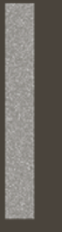
Selected region of the original image
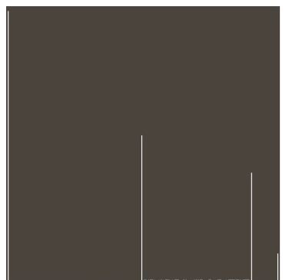
- Histogram of the green component of the selected region

How could you remove the green noise? Please finish the code fragment.
import cv2 as cv
import numpy as np

img = cv.imread(‘./test.bmp’)
for r in range(0, img.shape[0]):
for c in range(0, img.shape[1]):
# access the green value of each pixel
if img[r][c][1] > 100:
# if it’s above a threshold set it to 0
img[r][c][1] = 0

(b)
Selected region of the original image

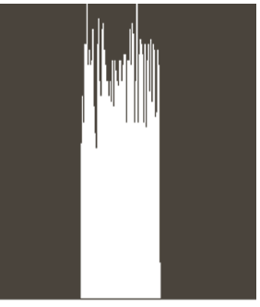
(b)Histogram of the green component of the cut region
How could you remove the green noise? Please finish the code fragment.

Im=imread(‘./test.bmp’);
…
your solution goes here.
…

…
imwrite(im_o,’./test_output.bmp’);

